**RCI 21+ FORD BRONCO 4 DOOR ROCK SLIDER INSTALLATION GUIDE**

**\*\* This install guide is applicable to 4 door Bronco vehicle configurations\*\***

1. Begin by unpacking and removing all components and hardware. Please verify that all hardware, components, and mounting components are present. Please reference your

original order invoice and verify all items are accounted for.

* 1. PLEASE NOTE: Sliders purchased with an RCI Black Powder Coat should be inspected thoroughly for any possible damage during shipment. Once the sliders have been mounted to the vehicle, RCI will no longer be able to assist with powder coat damage that may have occurred in transit.
  2. Sliders purchased in Bare Metal should be cleaned with Acetone and covered in a rust preventative (powder coat, paint, bed liner) before mounting to the vehicle.

1. Start by removing all OEM rock rails or side steps from the truck.
   1. Disconnect all plastic clips that are holing wiring harnesses or brake lines to the frame

**Arrows show which clips need to be disconnected before install**

Figure 1

**All wiring harness clips**

1. Collect the 2 (two) Bronco Speed Clip Brackets (#7) and install the 6 (six) M8 x 1.25 Speed Clips (#8) as shown in *Figure 2.*

**Arrow Location indicating front/outside**

**PASSENGER**

**DRIVER**

**SPEED CLIP BRACKETS (#7)**

**M8 SPEED CLIPS (#8)**

Figure 2

1. On the Passenger side behind the front tires on the lower side of the frame there is a slot where the speed clip bracket needs to be installed through. They need to be inserted in the same orientation as shown in *Figure 2.* The locating arrow will be pointing towards the front and the outside of the vehicle. RCI recommends using a small screwdriver to assist in aligning the bracket.

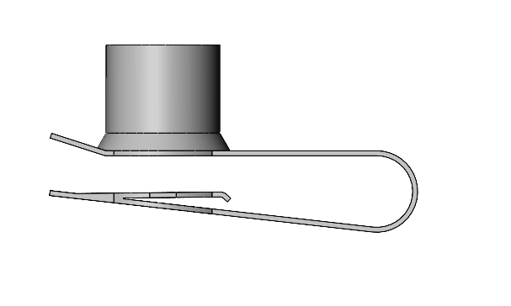

**Insert speed clip bracket through center slot**

**Passenger Side Frame**

**Lower view of speed clip orientation once installed into the frame**

**Rearmost Slot**

Figure 3

1. To help with installation, it’s recommended to partially thread one of the M8 x 1.25 x 30mm bolts (#9) with a 5/16” washer (#10) in the center speed clip to help align the outer most speed clips. Once the outer most speed clips are aligned with the holes in the frame, partially thread in 2 (two) more M8 x 1.25 x 30mm bolts (#9). Fully tighten the center M8 bolt (#9) using a 13mm socket and remove the outermost M8 bolts (#9) so that the threads are visible through the frame and ready for future install use.
2. Repeat steps 5 & 6 for the Driver side of the vehicle so that both Bronco speed clip brackets (#8) are installed into the frame and held in place by the center M8 bolts (#9).
3. Beginning with the Driver Side Rock Slider (#1). Ensure that there are no OEM or aftermarket bolts in the lower threaded holes on the frame (the provided M12 x40mm bolts (#11) will be installed in these locations).

**Rear of Vehicle**

**Holes used for mounting slider on driver side**

Figure 4

1. Once the frame is clear and the speed clip bracket is installed collect 2 (two) of the M12 x 1.75 x 40mm bolts (#11) with 2 (two) 1/2” Washers (#4).
2. Lift the Driver Side Rock Slider (#1) into position with the smaller frame plate towards the front of the vehicle. Begin threading the 2 (two) M12 bolts (#11) into the bottom of the frame centering the mounting slots on the frame with the threaded holes. The use of a floor jack, stool, or a helping hand is recommended until fasteners are installed.

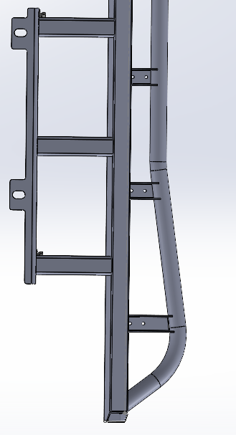

**Rear Driver section of slider (Bottom View)**

**Mounting locations for M12 Bolts (#11)**

Figure 5

1. Loosely tighten both M12 bolts (#11) so that there is slight adjustability in the slider.
2. Collect 2 (two) of the M8 x 30mm bolts (#9) with a 5/16” washer (#10) for each. Adjust the front of the small frame plate so the lower holes are aligned with the threaded speed clip holes. Hand thread the two M8 bolts (#9) with 5/16” washers (#10) until tight.

Figure 6

1. Once all 4 (four) lower bolts are threaded (#9 & #11), tighten them down until the slider frame plate is snug to the frame of the truck and then loosen each bolt ¼ of a turn.
   1. NOTE: The lower bolts will be fully tightened in step 17.
2. Collect 3 (three) of each: 7/16” x 5.5” Carriage Bolt (#3), Bronco Carriage Bolt Plate (#2), 1/2” Washer (#4), 7/16” Split Lock Washer (#5), and 7/16” Hex Nut (#6).
   1. Assemble each carriage bolt in the order depicted in *Figure 7*. Thread the 7/16” Hex Nut (#6) down an inch from the bottom of the carriage bolt.

**Insert bolt head through** **frame**

Figure 7

#3

#4

#5

#6

1. Feed each carriage bolt through the 3 (three) 1” holes on the slider frame plate with the head of the bolt facing towards the center of the vehicle.
   1. If needed adjust 7/16” Hex Nut (#6) so that the carriage bolt head is visibly poking out the back side of the frame.
2. Take one of the Bronco Carriage Bolt Plates (#2) and hang it over the square section on the 7/16” carriage bolt (#3). These plates will secure the carriage bolts when tightening the nut to secure the slider frame plate. Hand tighten the 7/16” Hex Nut (#6) until the carriage bolt plate (#2) is snug against the frame. Reference *Figure 8*.

**Carriage Bolt Plate (#2)**

Figure 8

1. Repeat Step 16 for the remaining 2 (two) mounting locations.
   1. 1 (one) mounting location on small frontmost frame plate.
   2. 2 (two) mounting locations on main rearmost frame plate.
2. Use a 11/16” deep socket to fully tighten the 3 (three) 7/16” Hex Nuts (#6) until the slider frame plate is flush with the frame of the vehicle. Once the upper mounting locations are tight, re-tighten the 4 (four) lower mounting locations.
   1. For the driver side of the vehicle, re-install the brake line clips where applicable.
3. The Driver Side Rock Slider is now mounted!
4. Prepare the passenger side of the vehicle by removing the 2 (two) rearmost factory bolts holding the fuel tank skid plate in place.
   1. PLEASE NOTE: If your vehicle does not have an OEM fuel tank skid plate, RCI recommends using rachet straps or a floor jack to secure the fuel tank to the bottom of the vehicle before removing these 2 (two) supporting bolts.
   2. The OEM fuel tank or fuel tank straps will be reinstalled on top of the slider frame plate.

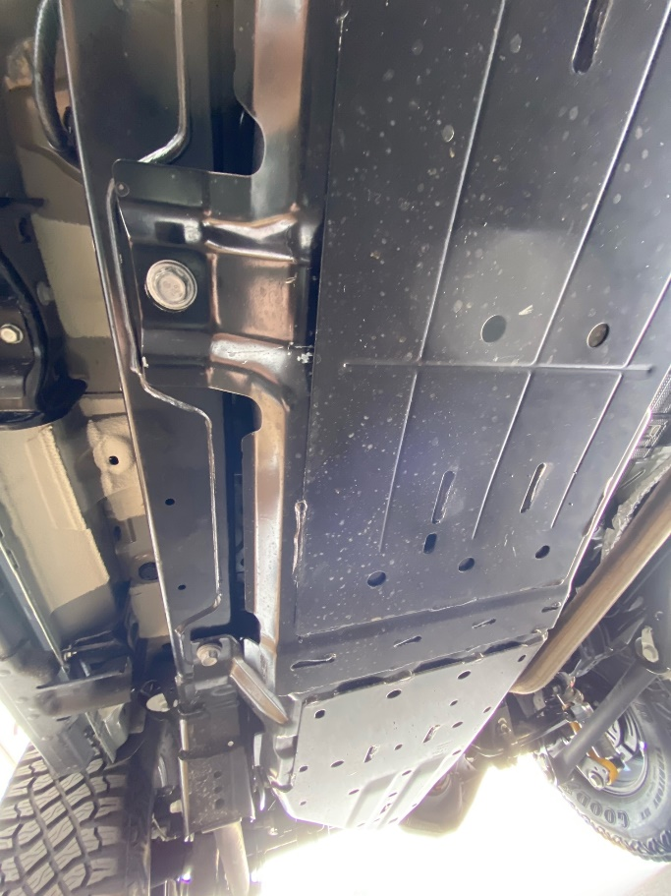

**Rear Passenger of Vehicle**

**Bolts to be removed before slider install**

Figure 9

1. Now repeat steps 7-18 for the Passenger Side Rock Slider (#1).
   1. For step 10, ensure that the fuel tank skid plate or fuel tank straps are being re-installed on top of the slider frame plate using the same M12 x 40mm bolt (#11).
   2. PLEASE NOTE: the OEM fuel tank bolts can be re-used in place of the provided M12 x 40mm (#11) hardware if desired.
2. This concludes the installation of the RCI 21+ Ford Bronco 4 Door Rock sliders!

**Share your new install with us on social media!**

**We love seeing our products out in the wild!**

**www.rcimetalworks.com**

[**sales@rcioffroad.com**](mailto:sales@rcioffroad.com)

**970-797-3089**

REV: 1 | 01/26/2022

Created: AWM

Disclaimer: The products sold by RCI Metalworks are intended for off –road use only, should not be modified, and are for use only on the vehicle(s) specifically stated. RCI Metalworks makes no warranties express or implied, including of fitness for a particular purpose or merchantability. RCI Metalworks will not be liable for any damages arising out of the use or misuse of its products. It is the customers' responsibility to ensure the products are safely and properly attached to the vehicle, and all products should be installed by trained professionals. We strive to maintain extremely high quality standards; however, all RCI Metalworks products are individually handcrafted, may vary slightly, and may contain minor imperfections. Due to the nature of raw aluminum, the material may have minor scratches and other blemishes caused by the manufacturing process, especially on the back side of product.  RCI Metalworks is constantly seeking to improve its products and reserves the right to make changes to any product.