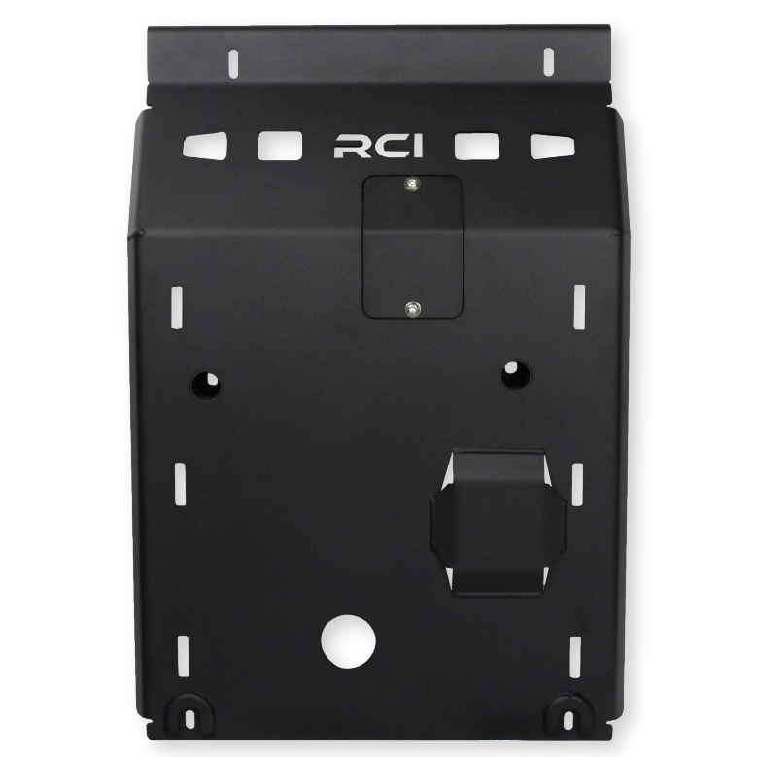
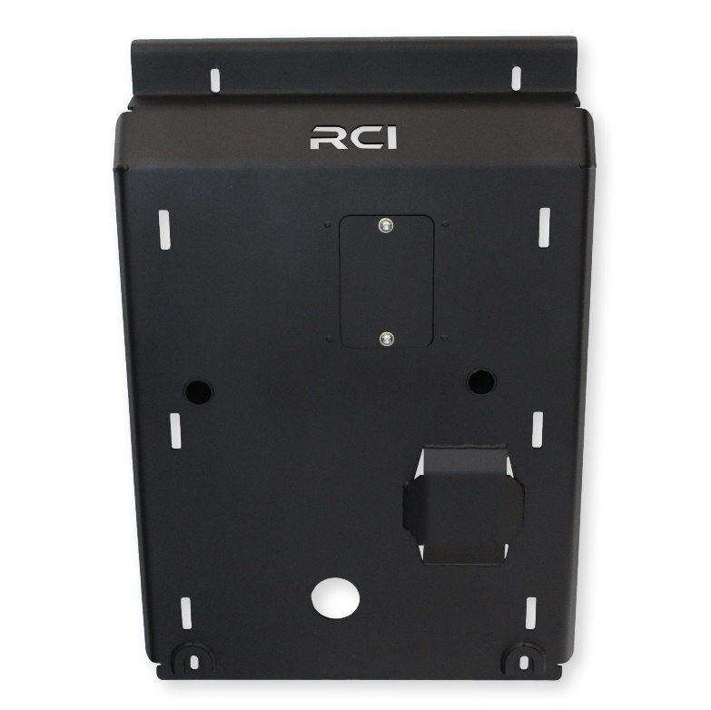
RCI 10+ TOYOTA 4RUNNER ENGINE SKID PLATE INSTALLATION GUIDE
**This install guide is applicable to our 10+ 4Runner Engine Skid Plate, NON-KDSS and KDSS**

TOOLS REQUIRED:
Description
3/8” or 1/2" Socket Wrench and Socket Set
Socket Wrench Extension Set

INCLUDED HARDWARE:
Item | Description | QTY
H1. | M8 x 1.25 x 30mm Hex Bolt | 4 ea.
H2. | M8 x 1.25 x 40MM Hex Bolt | 2 ea.
H3. | 5/16” Washer | 6 ea.
H4. | 3/8” x 1/2” Nylon Spacer | 2 ea.
H5. | M8 x 1.25 x 25mm Button Head Bolt  (pre-installed on skid) | 2 ea.
H6. | 1/4" Washer  (pre-installed on skid) | 2 ea.
H7. | M8 Steel U-nut  (pre-installed on skid) | 2 ea.

INCLUDED COMPONENTS:
Item | Description | QTY
C1. | 4Runner Engine Skid Plate | 1 ea.
C2. | Oil Filter Access Door  (pre-installed on skid) | 1 ea.

INSTALLATION STEPS:

- Begin by unpacking and removing all components and hardware. Please verify that all hardware, components, and mounting components are present. Please reference your original order invoice and verify all items are accounted for.

- Remove OEM Toyota installed skid plate present under the engine and radiator. The OEM skid plates usually consist of two separate plates. The secondary plate sitting between the front suspension crossmembers and the primary plate between the front bumper and the front crossmember of the front suspension. These are easily removed with four bolts per plate (one on all corners). The primary plate will need to be hinged forward and lifted off. Once the plates have been removed, the factory mounting bars will be exposed. These mounting bars run forward and back on the vehicle and will remain on the truck with the RCI Engine Skid Plate. The OEM skid plates, and mounting hardware can be discarded.
  - PLEASE NOTE: Some trim levels of the 4Runner include a plastic splash guard between the front bumper and the radiator support crossmember. This splashguard often secures to the OEM skid plate by two small screws. Removal of this splash guard is required for installation of the RCI Engine Skid Plate.

- Align the 90-degree flange on the 4Runner Engine Skid Plate(C1) with the front of the radiator support crossmember on the truck. Using two M8x1.25x30mm Hex Bolts(H1) and 5/16” Washers(H3), hand thread one in the forward two mounting holes of the plate. These bolts should thread into the OEM mounting bar brackets on the radiator support crossmember. Leave the bolts loose.

- Hinge the rear most portion of the plate up to the rear crossmember of the front suspension. Temporarily hand thread one M8x1.25x40mm Hex Bolt(H2) and 5/16” Washer(H2) through the plate and into the newly aligned mounting hole on the vehicle frame. Thread the bolt far enough in to support the weight of the skid plate temporarily.

- Collect the second M8 Hex Bolt(H2), 5/16” Washer(H3), and the 3/8” Nylon Spacer(H4). Insert the M8 bolt and washer through the second rear most mounting location on the skid plate and place the 3/8” spacer on the bolt, between the skid plate and the vehicle frame. Thread the bolt far enough that the plate is supported.
  - Remove the bolt from step 4 and repeat step 5. Both rear skid plate bolts should have a spacer between the skid plate and the vehicle frame.
    - PLEASE NOTE: If you are installing the RCI Transmission skid plate simultaneously, the mounting order should be as follows: Ground>Engine Skid Plate>Transmission Skid Plate>3/8” Nylon Spacer>Vehicle frame.

- While supporting the 4Runner Engine Skid Plate(C1) hand thread all bolts installed in steps 3-5 to snug but NOT tightened. The tube mounts of the skid plate should now be aligned with the mounting points on the vehicle frame. Using the socket extension (no wrench) and the proper socket, apply an M8 Hex Bolt(H1) and 5/16” Washer(H3) to the socket and hand thread the bolt in the tube support. Snug with socket extension only, do NOT attach the socket wrench.

- With all mounting hardware in place, begin by tightening the forward and rear bolts first. Tighten to 30ft/lbs. Tighten the tube support bolts last. Tighten to 30ft/lbs.

- Installation of your new RCI 10+ Toyota 4Runner Engine Skid Plate is now complete!

Share your new install with us on social media!
We love seeing our products out in the wild!

www.rcimetalworks.com
sales@rcioffroad.com
970-797-3089
REV: 1 | 01/26/2022
Created: AWM

